Paper Title

Author¹, Author²
Organization¹, Organization²
Introduction
An introduction section is required to provide background to the reader about your paper and its context relative to the Generalized Intelligent Framework for Tutoring (GIFT). No abstract is to be included in your paper submission. You may used your accepted abstract as the basis for your introduction.
Each paragraph is to be separated by a single spaced line. Please, only use the styles provided in the gallery above. Text is the style to be used for the body of your paper.
Please define an abbreviation the first time that you use it.
Please use APA format for your citations and references.
Second Level Heading
Text is the style to be used for the body of your paper.
Third Level Heading
Text is the style to be used for the body of your paper.
Fourth Level Heading
Text is the style to be used for the body of your paper. Please do not go deeper than four heading levels.
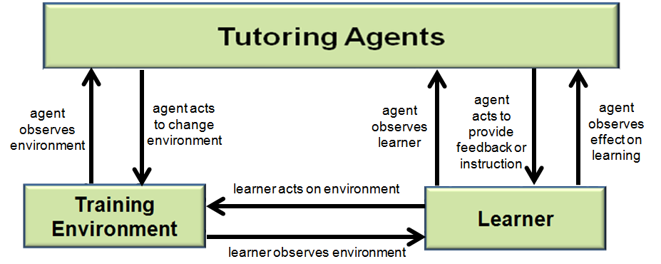
Figure 1. Use Caption Style for Figures and Tables
Note: Figure captions go below the figure (centered) and table captions go above the figure (centered). All figures, tables, and images must be original and not previously published.
Conclusions and Recommendations for FUTURE research
Please provide conclusions and recommendations for future directions for GIFT and intelligent tutoring system (ITS) research.
References
Note: Please use APA format for your references, and please use reference style provided, it will automatically place a 6pt space between each reference. Also, please make sure that there are no missing references prior to submitting the paper.
Goldberg, B., Owens, K., Hellman, K., Robson, R., Blake-Plock, S., Hoffman, M. & Gupton, K. (2021). Forging proficiency and readiness through an experiential learning for readiness strategy. In Proceedings of the 2021 Interservice/Industry Training Simulation and Education Conference (I/ITSEC). Orlando, FL.
Sottilare, R., Brawner, K., Goldberg, B. & Holden, H. (2012). The Generalized Intelligent Framework for Tutoring (GIFT). US Army Research Laboratory.
Sottilare, R. A., Brawner, K. W., Sinatra, A. M., & Johnston, J. H. (2017). An updated concept for a Generalized Intelligent Framework for Tutoring (GIFT). GIFTtutoring. org, 1-19.
Sottilare, R., Goldberg, B., Brawner, K., & Holden, H. (2012). A modular framework to support the authoring and assessment of adaptive computer-based tutoring systems (CBTS). In Proceedings of the Interservice/Industry Training Simulation & Education Conference, Orlando, Florida, December 2012.
Sottilare, R., Holden, H., Goldberg, B., & Brawner, K. (2013). The Generalized Intelligent Framework for Tutoring (GIFT). In Best, C., Galanis, G., Kerry, J. and Sottilare, R. (Eds.) Fundamental Issues in Defence Simulation & Training. Ashgate Publishing.
VanLehn, K., Lynch, C., Schulze, K., Shapiro, J. A., Shelby, R., Taylor, L., et al., (2005). The Andes physics tutoring system: Lessons learned. International Journal of Artificial Intelligence and Education, 15(3), 147–204.
Vygotsky, L.S. (1978). Mind in Society: The development of higher psychology processes. Cambridge MA: Harvard University press.

ABOUT THE AUTHORS
Note: Please provide a short (<100 word) bio for each author listed in your paper. Use the author bio style and bold the author’s title and name. Please see the example below.
Dr. First Name Last Name is a researcher at…

