An Effectiveness Evaluation of Blended Adaptive Learning Approaches
Cadet Joshua Rea¹, Cadet Payton Rengel¹, Barbara Buck, Ph.D.², Benjamin Goldberg, Ph.D.³ Ericka Rovira, Ph.D.¹
¹U.S. Military Academy West Point, NY 10996, USA
²The Boeing Company, St. Louis MO 63166, USA
³U.S. Army Natick Soldier Research and Development Center, Orlando FL 32826, USA

INTRODUCTION

In this paper we describe an aggregate prototype of adaptive learning that leverages two distinct implementations. The first implementation is the U.S. Combat Capability Development Command – Soldier Center’s (CCDC-SC) Generalized Intelligent Framework for Tutoring (GIFT), and the second is the Boeing Intelligent Tutoring System (ITS). The product of combining these efforts is an integrated adaptive learning solution that merges pedagogical techniques inherent to their respective platform. This presentation highlights previous efforts to create a seamless adaptive learning experience on the part of the student using both adaptive learning implementations, as well as prototypes developed for the same content using either the GIFT or the Boeing ITS implementation separately. The result is three distinct prototypes: the blended GIFT/Boeing ITS prototype, the GIFT alone implementation, and the Boeing ITS-alone implementation. An effectiveness study was conducted at West Point using cadets as subjects to compare the three implementations. Results of that study are presented, as well as lessons learned and plans for follow-on activities based on study results.

As part of a three-year Cooperative Research and Development Agreement (CRADA), Boeing and CCDCSC developed an integrated adaptive instructional system in which we combined the Army’s GIFT adaptive learning framework with the Boeing ITS capabilities. A prototype was developed using the resulting architecture, which uses an aircraft maintenance scenario as the use case with aspects of troubleshooting and part replacement. It uses the Adaptive Course Flow Course Object (i.e. knowledge assessment functionality and individual difference categorization) within GIFT to sequence course content to the student and to adapt course content based on ongoing student parameter characterization (Goldberg, Hoffman & Tar, 2015). The Boeing ITS capability provides lesson content for required learning and adapts within-lesson content to maximize a student’s ability to successfully pass lesson modules on the initial attempt.

The final evaluated practice module is completed using Boeing’s virtual maintenance capability known as Extended Reality Learning Framework (XRLF). As part of the final practice assessment, students don a virtual reality (VR) headset, and using two 3D VR hand controllers, they can navigate to various places on the aircraft, perform the required troubleshooting tasks while adhering to required safety protocols, diagnose the fault and replace the faulty part (all concepts trained prior to execution). Automated real-time performance assessment and adaptive learning capabilities within the XRLF system score the student on targeted learning objectives, provide on-demand student assistance to help locate components, and provide scoring to determine whether the student passes or fails the practical assessment.

In addition to the integrated prototype, we developed a Boeing-only ITS lesson and a GIFT-only lesson. The Boeing ITS lesson had the students complete all modules of the training curriculum, without the tailoring of content based on an initial pre-test. It uses the ITS capability in the practice modules to maximize training effectiveness and efficiency as students complete the course. The GIFT-only condition uses the pre-test to tailor student content by configuring the lesson to deliver material only on concepts not meeting the mastery criteria. In addition, knowledge checks and remediation loops are provided at a concept by concept basis based on the Adaptive Course flow directed by GIFT’s Engine for Management of Adaptive Pedagogy (EMAP; Goldberg et al., 2015). The GIFT-only version does not have practice modules as part of the adaptive course flow.

A training effectiveness study was designed to assess the relative effectiveness of these different implementations of adaptive learning. The effectiveness study was conducted by Firsties (i.e. Senior Cadets) at West Point using fellow cadets as participant volunteers. The goal of the study is to assess these three implementations of overall curriculum adaptation to determine which optimized student performance, using measures of time to competence, performance outcomes, training transfer, and knowledge retention. Based on the results of this study, modifications to both adaptive training frameworks will be recommended to better meet needs. This presentation will conclude with some of the lessons learned as part of the development effort.

METHODOLOGY

Participants
Fifty-one cadets enrolled at the United States Military Academy (USMA) at West Point participated in the training effectiveness study. A power analysis was conducted to find the number of participants that will result in significant data. The analysis reported that 66 participants (22 per condition) would result in significant data. USMA cadets were targeted because they represent a population of future Officers who will possibly interact with ITS integrated platforms. They also represent a university student population who lack specific skill sets, which is a key focus of operational ITSs. The population of cadets consisted of fortyfour males and seven females. Participant age ranged from 18 to 24 years old and all were registered in either PL100 General Psychology or PL300 Military Leadership courses and received 10 bonus points for their participation. Data from 12 participants were removed due to time constraints, leaving thirty-nine useable sets.

Training Task

The training task is based on instructing a student on a basic aircraft maintenance procedure with aspects of troubleshooting and part replacement. In order to perform the task correctly, the student must understand some basics of electrical safety, as well as multimeter usage. Once they have demonstrated an understanding of those basic concepts, then they are taught the fault diagnosis and repair procedure. Those three components (electrical safety, multimeter usage, and fault diagnosis procedure) became the learning objectives used in GIFT to create the adaptive learning capability.

Apparatus
The experiment was administered in a single room with one station configured for data collection. The station consisted of a commercial-off-the-shelf laptop with a 15” display, an HTC Vive virtual reality headset with two 3D VR hand controllers, and a set of over-the-ear headphones to control audio delivery. The three different adaptive learning prototypes (described below) were installed on the laptop.

Adaptive Learning Prototypes
The Generalized Intelligent Framework for Tutoring (GIFT). GIFT is an open-source, modular architecture designed to ease the burden of authoring, delivering, managing, and evaluating adaptive instruction across a broad array of domains (e.g., cognitive, affective, psychomotor, and social). As an adaptive instructional system (AIS), GIFT guides learning experiences by tailoring instruction and recommendations based on the goals, needs, and preferences of each learner in the context of specific domain learning objectives. GIFT is composed of tools, methods, interfaces, and processes that capture and reinforce best instructional practices, effective learning strategies, and tactical actions for both individual learners and teams. Emerging capabilities include: user dashboards, data analytics, automated content curation, automated after action reviews, and standard messaging for reuse and interoperability. For this study, GIFT was used to create a training session (GIFT-Alone) which uses a pre-test to tailor student content by implementing the within-module adaptation and remediation built-in knowledge checks.

The Boeing Intelligent Tutoring System (ITS). The Boeing ITS features 3 components: A Student Model, an Instructional Model, and an Expert Model. The Student Model implements a profile of dynamicallymaintained variables, each corresponding to one learning objective. These variables are evaluated over several observations. As a result, changes due to learning are reflected across exercises, as the score increases due to correct performance, or decreases as errors are made. The amount that scores are changed can be weighted according to the degree to which the action reflects mastery of the learning objective. Amount of change is also adjusted according to the degree of support provided to the student by the ITS in selecting this action. The Instructional Model responds to student requests for help or student errors with information on problem-solving strategies. The specificity of the information increases as additional requests are made or additional errors occur. The Instructional Model is also tasked with providing withinscenario feedback to guide the student, as well as performance summaries across all learning objectives at the end of the lesson scenario. The Expert Model is based on cognitive task analysis and provides methods to elicit detailed information from experts on how they approach a problem, and what actions they might take in seeking a solution, optimal and alternative paths to a solution, and their strategies for selecting actions at each step along those paths. The Expert Model directly encodes these solution paths. For each path, the model also captures the expert’s summary of the situation (representation of the problem) and the rationales for the possible next steps. For this study, the Boeing ITS was used to create practice modules used within the training session (Boeing-Alone). This session had the participants complete all modules of the training curriculum, without the tailoring of content based on an initial pre-test. It uses the ITS capability to maximize training effectiveness and efficiency by aiding students with hints, tailored feedback, and within-lesson remediation for those students who are struggling as they complete individual modules.

The Integrated GIFT/Boeing-ITS Hybrid Prototype. This prototype is a blended intelligent tutoring system that incorporates aspects of both the Boeing-ITS and GIFT. This hybrid system is configured to manage overall courseflow using within-lesson knowledge checks and based on the GIFT adaptive learning pedagogy (Rules, Example, Knowledge Check, Practice modules). Each participant in this condition will receive the knowledge pretest, and then study Rules and Examples on a specific concept as their Adaptive Course Flow object deems necessary, perform Knowledge Checks on that material with remediation loops, followed by interaction with the Boeing ITS Practice session before moving onto the next Adaptive Course
Flow object in the lesson. The basic lesson flow for this integrated hybrid prototype is illustrated in Figure
1.
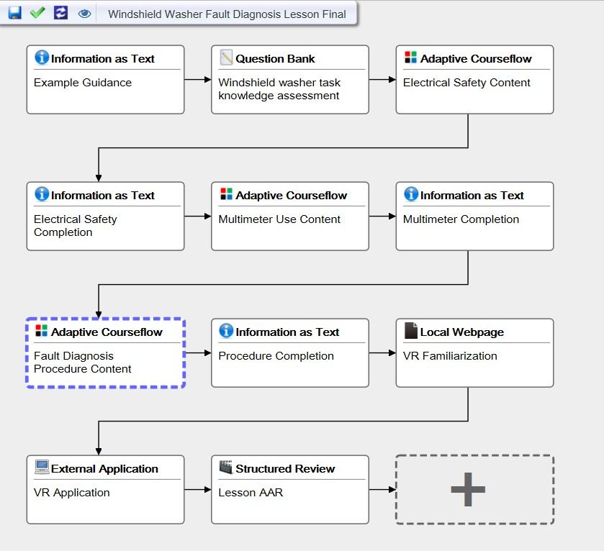
Fig. 1. Lesson flow for the integrated adaptive prototype.
Extended Reality Learning Framework (XRLF). The XRLF was designed to support a transfer post-test assessment to determine the benefit across the adaptive training conditions. The XRLF utilized Steam VR and the HTC Vive to allow participants to navigate to various places on the aircraft, perform the required troubleshooting tasks while adhering to required safety protocols, diagnose the fault and replace the faulty part. Automated real-time performance assessment and adaptive learning capabilities within the XRLF system score the student on targeted learning objectives, provide on-demand student assistance to help locate components, and provide scoring to determine whether the student passes or fails the practical assessment.

Procedure
Upon arrival participants signed an informed consent and were randomly assigned to one of three experimental conditions (Boeing-Alone, GIFT-Alone, or Hybrid). Next, they began interaction with the respective ITS by logging in with a unique participant number. Once started, a participant completed a demographics survey, then was shown a brief intro and overview of the training to come. The participants then took a pretest assessing initial knowledge levels. This metric was used to determine learning gains following interaction with the training materials. The GIFT-Alone and Hybrid conditions also used the pre-test to tailor the training session to the participant’s specific knowledge needs; however, the Boeing-Alone condition did not. The pre-test took approximately 5 minutes.

Next, the each ITS directed a set of slides developed to train the subjects to perform a maintenance task on a Boeing P8 aircraft. The course materials were self-guided and built using interactive multimedia. All participants interacted with the same basic courseware, but with different fundamental approaches to ITS training, as described above. The training courseware, consisting of three modules: Electrical Safety, Multimeter Use, and Fault Diagnosis Procedure, was completed according to the pedagogy established according to their assigned training condition. On average, training took approximately 35 minutes.

Once a participant successfully completed all the training modules, they moved into a tutorial for the virtual reality simulation. This brief tutorial exposed the participants to the equipment, the VR environment, and the scenario. After completing the tutorial, the participants donned the HTC Vive headset and 3D hand controllers. Once the participant adjusted the equipment to their liking, they began to orient themselves within the VR environment. The participants were then prompted to familiarize themselves with the controls within the VR environment before they began the scenario. Once familiarized, the participants began the scenario. The study would conclude when the participant completed the VR simulation. The VR simulation took on average 20 minutes and the whole study lasted approximately 55 minutes. Figure 2 demonstrates the apparatus in use as a cadet performs the transfer task in the virtual environment.

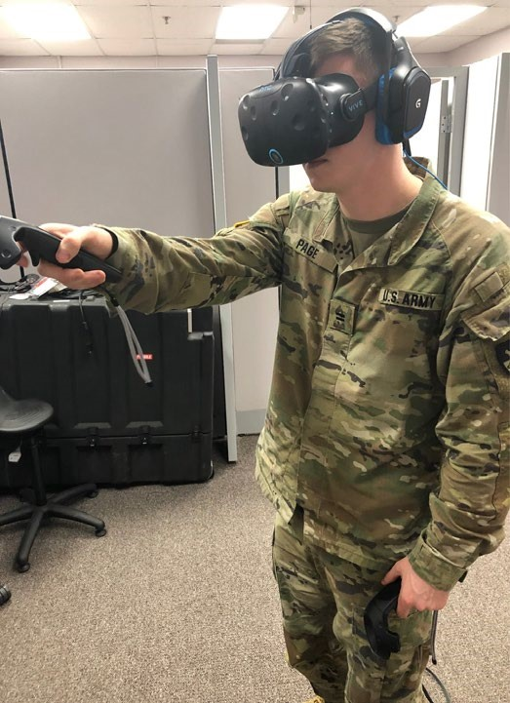
Fig. 2. Cadet performing training transfer task in the virtual environment.

Experimental Design
This experiment followed a between-subjects design. The independent variable for this study is the type of ITS that is interacted with. This means that the independent variable is a single factor with three levels (GIFT, Boeing ITS, and Hybrid), since we are trying to test the effectiveness of the three different tutoring systems. Level one is the GIFT system, the GIFT-alone lesson uses the pre-test to tailor student content by implementing a within-module adaptation and remediation afforded by built-in knowledge checks. Level two is the Boeing ITS, the Boeing-alone lesson had the students complete all modules of the training curriculum, without the tailoring of content based on an initial pre-test. Instead, it uses the ITS capability to tailor content and personalize instruction within the individual practice modules. Lastly, level three is the Hybrid training, which is a combination of the GIFT and ITS systems which uses the remediation aspects of GIFT and allows users to receive the individually-tailored aspects of the ITS practice modules. The course flow for each independent variable is shown in Figure 3. The dependent variable in this experiment is the performance in the VR scenario, which includes time on task, completion of key learning objectives, and overall performance. This will allow us to determine effects of the three different training scenarios on the performance of the task, allowing us to determine training effectiveness. Due to a 55-minute time constraint, we used the VR scenario as the post-test metric to determine system effectiveness. In an ideal situation, a post-test which closely matched the pre-test would have been administered.

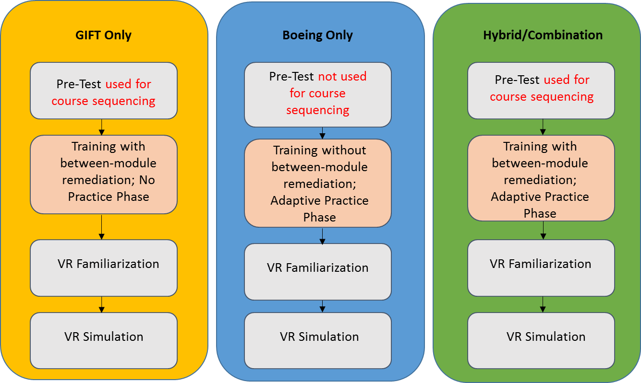
Figure 3. Shows the differences between the 3 conditions.

RESULTS

Data were analyzed using the IBM SPSS Statistics 25 software package. See Table 1 for a breakdown of the performance measure descriptive statistics.
Table 1. Performance Means and Standard Deviations (SD) across Pre- and Post-Test Measures
Concept | Pre-Test Mean % (SD) |  |  | Post-Test Mean % (SD) |  |  |  | Δ
 | GIFT N(13) | Boeing N(10) | Hybrid N(13) | GIFT | Boeing | Hybrid | GIFT | Boeing | Hybrid
Electrical Safety | 71.3  (12.2) | 70.9  (20) | 67.1  (20.1) | 76.9  (38.8) | 70.0  (42.2) | 88.5  (22) | 5.6% | -0.9% | 21.4%
Multimeter Use | 75.5  (11.3) | 67.3  (20.6) | 65.7  (24.9) | 61.5  (50.6) | 56.7  (49.8) | 76.9  (43.8) | -14% | -10.6% | 14.2%
Fault Diagnosis Proc. | 55.9  (18.1) | 50.0  (21.1) | 41.9  (24.2) | 82.7  (29.5) | 85.0  (64.8) | 94.2  (15.0) | 26.8% | 35% | 52.3%
Total Score | 67.6  (12.1) | 62.7  (17.0) | 58.3  (18.1) | 74.3  (25.8) | 72.2  (28.3) | 87.2  (23.5) | 6.7% | 9.5% | 28.9%

To examine the training’s overall impact on learning gains, a Repeated-Measures Analysis of Variance (ANOVA) was completed to look at both within- and between-subject effects across all concepts targeted within the lesson. To assess learning gains, both the pre-test and post-test measures were normalized by calculating a percentage of correct answers/actions observed. These percentage values were generated for each concept and for the overall score combined. Results show a significant within-subject effect on performance scores between pre- and post-test measures for the Fault Diagnosis concept, F(1, 35) = 12.896, p<.001 and the calculated Total Score values, F(1,35) = 9.742, p < .005; however, there is no observed effect of the training condition on performance gains, showing all conditions to produce a positive learning outcome regardless of the tutoring method applied. No other main effects or interactions were observed when examining performance differences between measures. Following, we ran a Univariate ANOVA to examine between-subject differences in performance within the final VR scenario alone. Results show no significant differences between conditions, F(2, 34) = 1.205, p = .312, despite the Hybrid condition outperforming the GIFT-Alone and Boeing-Alone conditions by 13% and 15% respectively when comparing the outcomes recorded in the VR post-test (see Table 1).

Next, we examined if the tutoring condition assigned had an impact on the amount of time required to complete the training. It was hypothesized the hydbrid condition would require significantly more time to complete, with the added instructional interatctions and remediation loops. To determine this, a Univariate ANOVA was completed to look at the total time across conditions, with results showing a significant difference, F(2, 34) = 6.942, p < .005. When doing post-hoc comparisons, the Hybrid condition (M = 3340 sec, SD = 492 sec), which combined both tutoring methodologies, took significantly longer to complete than both the GIFT-Alone (M = 2576 sec, SD = 791 sec; p < .05) and Boeing-Alone (M = 2204 sec, SD = 737 sec; p < .005) conditions (see Figure 4). No significant difference in time was observed when comparing the Boeing-Alone and GIFT-Alone conditions.

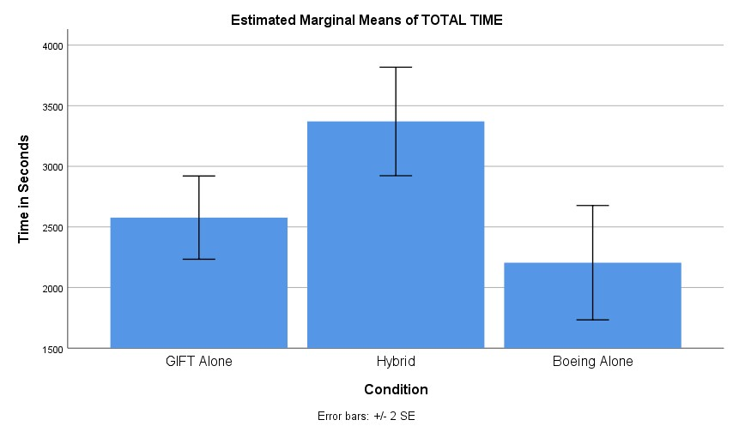

Figure 4. Total time to complete training across conditions (in seconds).
The final analysis looked at logged interaction data within the VR post-test scenario, which included participants requesting explanation hints, requesting locate item hints, and performing incorrect item selections during the procedure (see Figure 5 for visual representation). The analysis was performed to determine if those interaction points impacted performance, and if the assigned condition had an influence on the interactions observed during scenario execution. When examining correlations among the data, the total VR percentage correct score had a significant negative correlation with the attribute “locate item hints” (r = .384; p < .05) and a correlation approaching significance with the attribue “incorrect item selection” (r = .310; p = .066). Next, we ran a Univariate ANOVA against all three interaction variables to look at differences across conditions. While the results are not statistically significant, there are interesting observations. For the ‘Locate Item Hint’, the hybrid condition averaged far less than the other conditions (Boeing Alone: M = 7.40, SD = 9.3; GIFT Alone: M = 6.08, SD = 10.54; Hybrid: M = 2.54, SD = 6.11). The same is seen for the ‘Incorrect Item’ metric, showing the Hybrid participants to perform less errors in the scenario than the other conditions (Boeing Alone: M = 13.30, SD = 14.04; GIFT Alone: M = 7.77, SD = 11.88; Hybrid: M = 2.92, SD = 2.36). In this instance, the ANOVA outcomes are approaching significance, F(2, 34) = 2.845, p < .072. It should be noted that for each training condition, there were one or two individuals per condition who had the highest number of hints requested, more errors and higher overall training times. These individuals seemed to struggle regardless of the training condition they were in, and led to significant increases in the variance for the conditions. This increased variance probably led to the lack of significance between the training conditions.
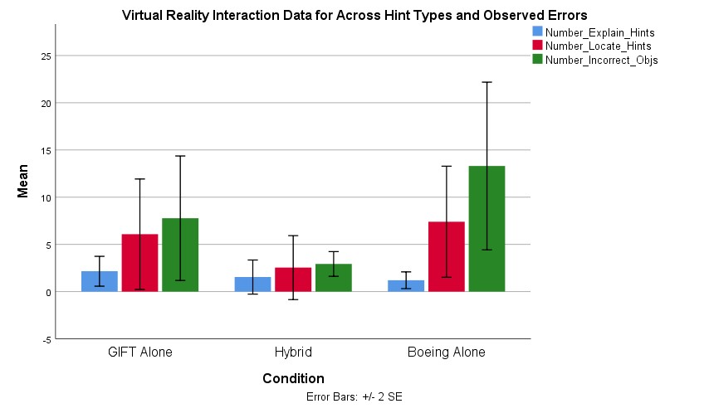

Figure 5. Visualization of VR Interaction Data Types across Conditions

DISCUSSION

While the results did not show significant differences in performance between experimental tutor conditions, the training in itself produced positive learning outcomes, showing benefit across each tutoring methodology. In addition, there is reason to believe that significant results might be observed had there been larger numbers of participants in each group. What can be seen is an apparent trend in performance scores that highlight larger overall post-test gains in the Hybrid condition (see Figure 6) when compared against the Boeing- and GIFT-Alone implementations. This finding is also supported by the analysis examining the interaction behaviors in the VR post-test. In this instance, the individuals receiving the hybrid condition were found to ask for fewer hints and performed less errors on average when compared against the other instructional methodologies.
From a cognitive psychology perspective, why would the Hybrid condition ultimately lead to higher performance gains and better overall learning? In this implementation, participants assigned to this condition are receiving two pedagogically-designed training interactions on the same defined set of concepts. While these individuals receive the information twice, and spend more time on the content, they receive the information in two distinctly different formats, which may lead to richer and more refined mental schemas of the domain space. In this instance, there is a trade-off to be considered. For a practitioner to develop a training design that takes significantly longer to complete (see Figure 4), the performance gains must be explicitly known and reliably observed. For instance, a novice population may see substantial benefits when spending more time in the initial schema development phase by interacting with different pedagogical formalizations of the same content. Further research is required to study the impact of tutoring methodologies on schema construction and refinement, and how the varying tutor approaches complement/support these processes, and when in the learning process those approaches are best utilized.
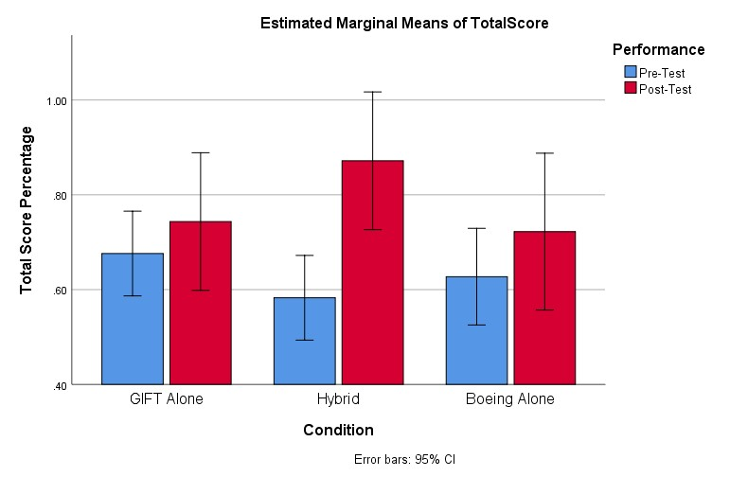

Figure 6. Visual comparison of pre-/post-test Total Score averages for each condition.
Another interesting observation from the study was looking at which concepts the training actually impacted and how the conditions supported different levels of prior knowledge. For both the GIFT-Alone and Hybrid conditions, if a participant tested-out of a concept by exhibiting high scores on the pre-test, those individuals skipped the didactic portion of training for each proficient concept. It is worth noting the Boeing-Alone conditions would receive the training regardless of their pre-test scores. For each concept, here are the number of participants who tested out based on pre-test scores, which required answering 9 of 11 selected questions correctly (Boeing-Alone is included to signify the numbers of participants who would have tested out if assigned to a different condition): (1) Electrical Safety (GIFT-Alone: 6/17; Hybrid: 5/14; Boeing-Alone: 7/11), (2) Multimeter Use (GIFT-Alone: 6/17; Hybrid: 4/14; Boeing-Alone: 3/11), and (3) Fault Diagnosis Procedure (GIFT-Alone: 1/17; Hybrid: 1/14; Boeing-Alone: 2/11). From these findings, participants’ prior knowledge on Fault Diagnosis Procedures was weakest, but results also show this concept to have the highest learning gains, regardless of the condition (see Figure 7). Despite the condition, the content provided assisted participants in acquiring the knowledge to successfully perform the fault diagnosis procedures within the VR scenario.
Also of interest, those individuals in the Boeing-Alone condition did not benefit from receiving the training content, regardless of showing proficiency on a concept (i.e., those who would have tested out of the training interaction if in another condition). This shows performance in the VR scenario was not impacted by allowing participants who show competency on a concept to skip the lesson portion of the training.

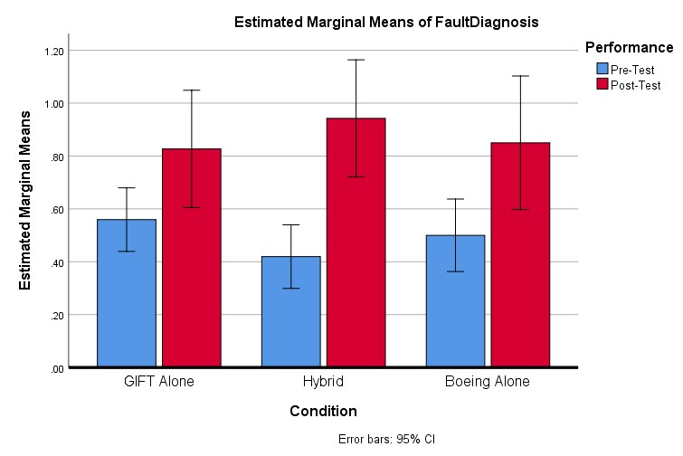

Figure 6. Pre-Test and Post-Test Scores across conditions on Fault Daignosis Procedure Items

CONCLUSIONS AND RECOMMENDATIONS FOR FUTURE RESEARCH

The results of this study show that training occurred in all conditions of intelligent tutoring. All three versions of intelligent tutoring varied in the implementation. For the GIFT-alone condition, the amount of content presented was tailored by pre-test performance. The Boeing-alone condition did not tailor content based on pre-test performance, but saw all content. The ITS portion of this condition focused on adaptivepractice applications of the task. The GIFT-alon condition did not have this practice module. The Hybrid condition combined aspects of the tailored content based on pre-test conditions with the adaptive practice modules. This condition resulted in trends for overall best performance, both in the final task performance, as well as fewer requested locate hints and incorrect actions.
Given schedule constraints, we were not able to include as many participants in the study as the power analyses indicated. Furthermore, a number of participants were dropped due to procedural complications. It is our belief that the trends observed would have reached statistical significance given additional participants.
What we can summarize for this study is that skipping content based on pre-test performance did not have a negative impact on transfer task performance. Furthermore, when combining aspects of the GIFT tailored content with the adaptive practice models present in the Boeing ITS, the Hybrid condition performance resulted in better overall performance, even if not always statistically significant. Furutre efforts to collect additional data could solidify these reulsts.
Finally, the task that was implemented for this study might not have been the ideal platform for testing some of these techniques. It was selected based on the availability of the virtual transfer environment. Additional research is needed on different training tasks to continue to tease out the relative benefits of these adaptive training techniques.

REFERENCES

Brawner, K. & Sottilare, R. (2018, June). Proposing Module Level Interoperability for Intelligent Tutoring Systems. In the Exploring Opportunities to Standardize Adaptive Instructional Systems (AIS) Workshop of the 19th International Conference of the Artificial Intelligence in Education (AIED) Conference, London, England, United Kingdom, June 2018.
Goldberg, B., Am burn, C., Ragusa, C., Dar-Wei, C. (2017). Modelling Expert Behaviour in Support of an Adaptive Psychomotor Training Environment: A Marksmanship Use Case. The International Journal of Artificial Intelligence in Education, 28, 194-224.
Goldberg, B., & Hoffman, M. (2015, June). Adaptive Course Flow and Sequencing through the Engine for Management of Adaptive Pedagogy (EMAP). In AIED Workshops.
Hutson, C. (2013). Virtual trainer saves time, money, increases skills. Retrieved from https://www.army.mil/article/95411/virtual_trainer_saves_time_money_increases_skills
Johnston, J. H., Goodwin, G., Moss, J., Sottilare, R., Osofsky, S., Cruz, D., & Grasser, A. (2015). Effectiveness Evaluation Tools and Methods for Adaptive Training and Education in Support of the US Army Learning Model: Research Outline. US Army Research Laboratory, 1-26.
Kirkpatrick, D. L. (1994). Evaluating training programs: the four levels. San Francisco: Emeryville, CA: Barrett Koehler; Publishers Group West.
Koedinger, K. R., Anderson, J. R., Hadley, W. H., and Mark, M. A. (1997). Intelligent Tutoring
Goes to School in the Big City. International Journal of Artificial Intelligence in Education, 8, 30-43.
Kulik, J., Fletcher, J. (2016). Effectiveness of Intelligent Tutoring Systems: A Meta-Analytic Review. Review of Ed curational Research, 86:1, 42-78.
McCullough, C. (2014). Simulated training saves money, prepares Soldiers for combat. Retrieved from https://www.army.mil/article/125385/simulated_training_saves_money_prepares_soldiers_for_combat.
Stevens, J., Kincaid, J. (2015). The Relationship between Presence and Performance in Virtual Simulation Training. Open Journal of Modelling and Simulation, 3, 41-48.
Sottilare, R. A., Goldberg, B. S., Brawner, K. W., & Holden, H. K. (2012). A Modular Framework to Support the Authoring and Assessment of Adaptive Computer-Based Tutoring Systems (CBTS). Proceedings of the Underservice/Industry Training, Simulation, and Education Conference, 1-13.
Vanern, K. (2011). The Relative Effectiveness of Human Tutoring, Intelligent Tutoring Systems, and Other Tutor in Systems. Educational Psychologist, 46:4, 197-221.
Whittington, C. D., & Campbell, L. M. (1999). Task-Oriented Learning on the Web. Innovations in Education & Training International, 36(1), 26.

ABOUT THE AUTHORS

CDT Josh Rea is a cadet at the United States Military Academy who is majoring in Engineering Psychology. As a part of this major this project served as his year-long capstone project. CDT Rea interned is the CCDC’s Learning in Intelligent Tutoring Environments (LITE) Lab in Orlando and worked with GIFT under Dr. Bob Sottiliare, Dr. Ben Goldberg, and Dr. Anne Sinatra.
CDT Payton Rengel is a cadet at the United States Military Academy who is majoring in Engineering Psychology. As a part of this major CDT Rea worked on this project for his year-long capstone project.
Dr. Barbara Buck is a research psychologist in Innovation & Product Management, part of the Boeing Global Services’ Training and Professional Services organization. Her recent efforts have focused on adaptive training, including integration adaptive training methods into lower-cost desktop solutions as well as more complex gaming and live simulation exercises. She has been instrumental in developing the Boeing adaptive authoring capability, and has conducted effectiveness research to evaluate the efficacy of adaptive training approaches, virtual reality applications and physiological measures of performance. Barbara holds a Ph.D. in Cognitive and Engineering Psychology from the University of Illinois.

Dr. Benjamin Goldberg, Ph.D. is an adaptive training scientist at the Army Research Laboratory’s SFC Paul Ray
Smith Simulation & Training Technology Center. He leads research focused on instructional management within ARL’s Learning in Intelligent Tutoring Environments (LITE) Lab and is a co-creator of the Generalized Intelligent Framework for Tutoring (GIFT).

Ericka Rovira, Ph. D. is a Full Professor of Engineering Psychology in the Department of Behavioral Sciences and Leadership at United States Military Academy, West Point, NY. Dr. Rovira is the Engineering Psychology Program and Lab Director. Her research investigates human autonomy interaction. Specifically, she investigates individual differences in cognition and how that impacts trust and reliance in autonomous systems e.g. robots.

