Towards Data-Driven Tutorial Planning for Counterinsur- gency Training in GIFT: Preliminary Findings and Lessons Learned
Randall Spain1, Jonathan Rowe1, Benjamin Goldberg3 , Robert Pokorny2, Bradford Mott1 and James Lester1 North Carolina State University¹, Intelligent Automation, Inc.², U.S. Army Combat Capabilities Development Command Soldier Center - STTC³
INTRODUCTION

Adaptive instructional systems (AISs) guide student learning experiences by tailoring instruction based on the individual goals, needs, and preferences of learners in the context of domain learning objectives (Sottilare, Barr, Robson, Hu & Graesser, 2018). A critical feature of AISs is the capability to dynamically guide and scaffold student learning. Leveraging recent advances in artificial intelligence and machine learning, it is possible to tailor training and educational experiences to individuals and teams of learners. Tutorial planning is a critical component of AISs, controlling how scaffolding is structured and delivered to learners. Tutorial planners operate at multiple levels, selecting problems for learners to solve and delivering tailored hints and feedback about specific problems. While research shows AISs can help to improve learning gains in many domains, devising computational models that determine when to scaffold, what type of scaffolding to deliver, and how scaffolding should be realized, is a critical challenge for the field.
Over the past several years the Generalized Intelligent Framework for Tutoring (GIFT) has emerged as a key exemplar of how these challenges in developing ITSs can be addressed at scale (Sottilare, Brawner, Goldberg, & Holden, 2012; Sottilare, Brawner, Sinatra, & Johnston, 2017). GIFT is an open-source domain-independent software framework for designing, deploying, and evaluating adaptive training systems. GIFT provides instructors with a suite of web-based tools for rapidly creating intelligent tutors, and it is linked to several ongoing research efforts to devise methods for automating key elements of the adaptive training authoring process. Many of these tools are available through GIFT’s Course Creator, which provides a drag-and-drop interface for devising adaptive training experiences across a range of domains.
In this paper, we describe results from a research program that aims to devise data-driven tutorial plan- ning policies that can be used in GIFT to present learners with adaptive remediation. In particular, we present preliminary results from a study involving over 500 learners who completed an approximately two-hour hypermedia training course that taught doctrinal concepts associated with counterinsurgency (COIN) and stability operations. The course leverages several unique enhancements to GIFT’s Engine for Management of Adaptive Pedagogy (EMAP) including a newly developed remediation module that presents learners with passive, active, or constructive forms of remedial feedback. The remediation activities are based on the ICAP framework for active learning (Chi, 2009) which predicts that interactive remediation (e.g., peer dialogue) is more effective for learning than constructive remediation (e.g., writing an explanation), constructive remediation is more effective than active remediation (e.g., reading and highlighting a passage), and active remediation is more effective than passive remediation (e.g., reading a passage without doing anything else). Our analyses address several fundamental questions that are essential for developing effective reinforcement learning policies. We also describe lessons learned from deploying the training course on Amazon’s Mechanical Turk (MTurk) and utilizing GIFT’s Event Reporting Tool to extract data in support of reinforcement learning analysis. The paper concludes with a discussion of upcoming plans to devise tutorial policies using reinforcement learning techniques, as well as future directions for incorporating these policies in GIFT to enhance its ability to provide learners with effective and efficient adaptive remediation in future courses.
RESEARCH CONTEXT

A significant challenge that authors face when designing AISs is determining when to scaffold learners, what type of scaffolding to deliver, and how scaffolding should be realized. One reason for this challenge is the wide range of pedagogical strategies and tactics that can be implemented in AISs, as well as a lack of empirically grounded guidance about the relative contribution of different adaptive interventions on learning outcomes (Durlach & Ray, 2011). Another challenge facing adaptive course designers is that rules that drive adaptive pedagogical decisions often must be manually engineered, which can significant- ly increase the time required to author adaptive instructional materials (Aleven, McLaren, Sewall, & Koedinger, 2009; Sottilare, 2015).
Recent developments in artificial intelligence and machine learning have introduced opportunities to reduce the authoring burden of AISs by devising data-driven tutorial planning policies that can automati- cally control how pedagogical support is structured and delivered to learners to create personalized learning experiences (Rowe & Lester, 2015; Williams et al., 2016; Zhou, Wang, Lynch, & Chi, 2017). Tutorial planning is an important component of ITSs that controls how instructional interventions are structured and delivered at the macro-level (e.g., selecting problems for learners to solve) and micro-level (e.g., delivering tailored hints and feedback about specific problems). Tutorial planning techniques are complementary to advances in intelligent tutoring system authoring, including authoring tools imple- mented in GIFT, to address the challenges inherent in constructing adaptive training materials.
Reinforcement learning techniques have shown promise for automatically inducing tutorial planning rules that optimize student learning outcomes and do not require pedagogical rules to be manually programmed or demonstrated by expert tutors. Reinforcement learning is a category of machine learning that centers on devising software agents that perform actions in a stochastic environment to optimize some concept of numerical reward (Sutton & Barto, 1998). In reinforcement learning, the agent induces a control policy by iteratively performing actions and observing their effects on the environment and accumulated rewards. Tutorial planning can be formalized as a reinforcement learning task in which the tutor (i.e., agent) aims to make pedagogical decisions (i.e., actions) that will affect its environment (i.e., the trainee and his/her learning environment) to optimize student learning outcomes (i.e., rewards). In our case, the pedagogical decisions are choosing between ICAP-inspired remediation activities, and the tutorial planner’s objective is to optimize student learning in an adaptive hypermedia-based training course for COIN.
Because reinforcement learning techniques are data-intensive, a critical goal of our study was to obtain a large dataset consisting of trainee responses to different types of instructional remediation activities. To meet this objective, we developed an adaptive hypermedia-based training course in GIFT that builds upon materials from the UrbanSim Primer. Originally developed by the USC Institute for Creative Technolo- gies, the UrbanSim Primer is a hypermedia-based learning environment that provides direct instruction on key concepts and principles of COIN doctrine. Our GIFT-based version of the UrbanSim Primer course was designed to: (1) contain numerous opportunities for learners to receive instructional remediation; (2) be deployable through online crowdsourcing platforms, which enabled efficient distribution to many learners for data collection purposes; (3) enact an exploratory (i.e., random) remediation policy in order to broadly sample the space of possible pedagogical decisions; (4) assess learning gains using pre-and post- knowledge tests, and (5) collect trace data from participants as they interacted with the training course (i.e., how many times learners received remediation, how long they spent interacting with the different forms of remediation, correctness of responses, helpfulness ratings of remedial content, etc.) which would enable exploration of different state representations and reward functions for inducing reinforcement learning-based tutorial policies.
In the following sections, we describe the results of a large human subject’s study that we recently completed as well as the preliminary analyses that serve as prerequisites for developing tutorial policies using reinforcement learning techniques. The research questions guiding our initial set of analyses included: How effective was the course in promoting learning gains? How frequently did learners receive remediation? How long did learners spend interacting with each form of remediation? Which form of remediation was most effective for helping learners overcome an impasse?
METHODOLOGY
Participants
To meet our goal of facilitating broad distribution to many learners, we recruited participants through Amazon’s MTurk platform. Participants were required to be at least 18 years of age, reside in the United States, have completed at least 50 MTurk tasks, and have obtained a task completion success rate of at least 95% to be eligible for the study. A total of 533 participants (42% female, ages ranged from 18 - 65) completed the training course, which lasted approximately 2 hours. Participants received $8 for complet- ing the full training course. Thirty-five percent of participants had a bachelor's degree, 25% had some college education, 11% had a master’s degree, and 11% had a high school diploma. Two percent of the sample reported being extremely familiar with COIN principles and doctrine; 12% reported being extremely interested in learning about COIN topics.
Hypermedia Training Course
The hypermedia-based training course was based upon materials from the UrbanSim Primer. The course was authored in GIFT and organized into 4 chapters. Each chapter contained a series of short videos, recall questions, and remedial training content designed to teach common themes, terminology and principles of COIN operations (Rowe, Spain, Pokorny, Mott, Goldberg, & Lester, 2018). The videos were approximately 90 seconds and covered topics such as “Identifying the center of gravity in COIN opera- tions”, “Defining intelligence preparation for the battlefield”, and “Understanding lines of effort in COIN operations.” The recall questions, which were presented in multiple choice format, assessed the content covered in the videos. The remediation interventions were structured according to Chi’s ICAP framework (Chi, 2009) and required students to either passively, actively, and constructively engage with remedial feedback upon missing a quiz question. The hypermedia course also included a set of web-based surveys designed to collect information about participants’ age, education, interest in counterinsurgency opera- tions and military science topics, and goal orientation, as well as parallel forms of a 12-item pre-and posttest that measured knowledge of COIN topics, terminology, and principles. The hypermedia course contained a total of 12 multimedia videos, 39 multiple-choice recall questions, and 168 ICAP inspired remediation files. Participants advanced through the training course at their own pace and were not allowed to review previously completed lessons or videos.
Procedure
A brief description of the study was posted on the MTurk website. Participants who were interested in the study reviewed and electronically signed an informed consent form that described the study’s purpose, risks, benefits, and compensation requirements. Afterward participants proceeded to the training course which was hosted on the cloud-based instance of GIFT.
The course began with a general message that welcomed participants to the training course. Following this introduction, participants completed a demographic questionnaire that gathered information about their age, years of education, and familiarity with COIN topics and concepts. Then, they completed a goal orientation questionnaire that measured task-based and intrinsic motivation to learn (Elliot & Murayama, 2008) followed by a 12-item pretest that measured prior knowledge of COIN principles and terminology. After completing the pre-training surveys, participants began the adaptive hypermedia COIN training course. Participants watched a series of narrated videos that covered lesson topics such as the importance of population support, processes for intelligence gathering, and issues in successful COIN operations. After each video, participants completed a series of recall questions that consisted of single or multi- concept review items that aligned with the course’s learning objectives. Single concept review questions required learners to recall and apply concepts presented within the video lesson. Multi-concept review questions required learners to demonstrate a deeper understanding of course material by integrating concepts from multiple lessons. Following a missed question, participants received ICAP-inspired remediation that required them to either: (1) passively re-read the narrated content that was just presented in the lesson video; (2) re-read the video content and actively highlight the portion of text that answered the recall question that was just missed; or (3) re-read the text and constructively summarize the answer to the recall question in their own words. The active and constructive remediation prompts also included expert highlighting/summaries that asked students to self-evaluate the accuracy of their responses (see Figure 1).
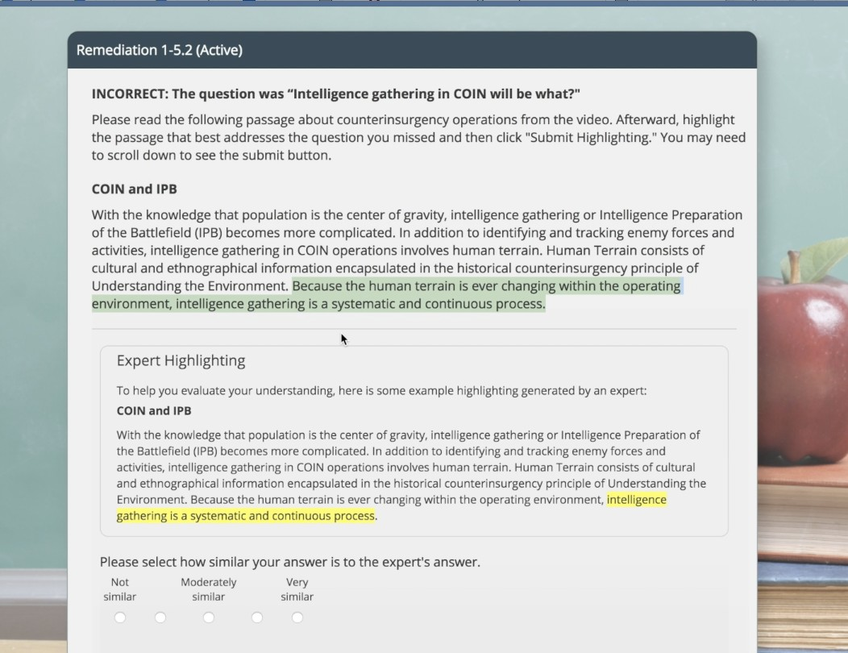
Figure 1. Example active remediation activity.
The course also included a “no remediation” prompt that only provided students with minimal feedback before being asked to re-answer the quiz question. The course used a random assignment policy that determined whether students received passive, active, constructive, or no remediation after each incorrect item response. Students continued to receive remediation until they demonstrated concept mastery (i.e., correctly answering the recall question). In addition to the ICAP-inspired remediation prompts, the training course also monitored how long students engaged with the video-based lessons and provided prompts to those participants who advanced through the videos too quickly or too slowly.
Upon finishing the final lesson and quiz, participants completed a series of post-training surveys that included a multiple-choice posttest to measure retention of the concepts and principles presented in the training and a short questionnaire to collect opinions about the training experience. After completing these activities, participants received a debriefing message, they were thanked for their participation, and they received a unique completion code that could be used to verify course completion through the MTurk website.
PRELIMiNARY RESULTS
A goal of the overall research program is to investigate the benefits of different tutorial interventions for improving student learning in adaptive training environments. Towards this goal, and prior to developing any reinforcement learning-based policies, we first conducted a set of preliminary analyses to identify how well participants performed in the course, how often learners received remediation, and how long, on average, learners spent interacting with the different intervention forms.
Learning Gains
Participants’ pre-and posttest scores as well as normalized learning gains were analyzed in order to determine if the course was effective in promoting participants’ knowledge of COIN concepts, terminolo- gy, and principles. Scores from the 12-item pretest revealed that participants had low prior knowledge of the concepts covered in the course (M= 4.29, SD = 2.20). A post hoc analysis using a two-sample test t- test indicated that post test scores were significantly higher (M= 8.22, SD = 3.11) than pre-test scores, t(509) = 30.79, p <. 001. An analysis of participants’ normalized learning gains showed the course was effective in meeting its instructional objectives (M = .52; SD = .11) and that participants benefited from completing the course.
Remediation
Next, we examined how often participants received remediation in the course. Reinforcement learning techniques are data intensive, and therefore it is critical that the dataset contain a large number of remedi- ation instances to broadly sample the space of possible tutorial interventions and support inducing data- driven tutorial policies. Results showed that the training corpus included a total of 5,189 instances of remediation. Individual participants typically received multiple instances of remediation in the range of 1 to 113 (M = 10.08, SD = 12.58). Although the course was designed to implement a randomized control policy, frequency statistics showed that 40% of all remediation interventions were active-interventions, 40% were constructive, 10% were passive, and 10% were no-remediation. A closer inspection of the remediation data showed that 5% of the sample received only one instance of remediation (i.e., partici- pants missed only one recall question and therefore received only one remediation intervention) and that 75% of the sample received up to 10 instances of remediation.
Following these analyses, we analyzed participants’ completion times for each form of remediation to determine whether participants spent more time completing the constructive and active remediation activities, which were designed to evoke more cognitive engagement, compared to the passive remediation activities, which were designed to be less engaging. Our analysis showed that participants spent the most time completing the constructive remediation activities (M = 75.96; SD = 32.30), a moderate amount of time completing the active remediation activities (M = 44.26; SD = 15.25), and the least amount of time viewing the passive remediation content (M = 27.64; SD = 21.60).
Further analyses showed participants spent less time on the constructive (r(39) = -.63, p <. 001) and active remediation (r(38) = -.58, p < .001) activities as they progressed through the training course, but there were no significant decreases in viewing time across passive remediation interventions (r(39) = -.20, p = .23). These results suggest that participants spent increasingly less time completing the constructive and active remediation activities as they progressed through the training course (Figure 2). Notably, participants spent almost 2 minutes, on average, completing constructive remediation activities when the training course began. By the end of the third chapter participants spent roughly a minute completing the constructive remediation activities, and by the conclusion of the course they were spending approximately 40 seconds completing these activities. A similar, albeit less pronounced trend is evident for the active remediation activities as well. These data suggest participants may have grown fatigued with the more cognitively engaging forms of remediation as the course progressed.
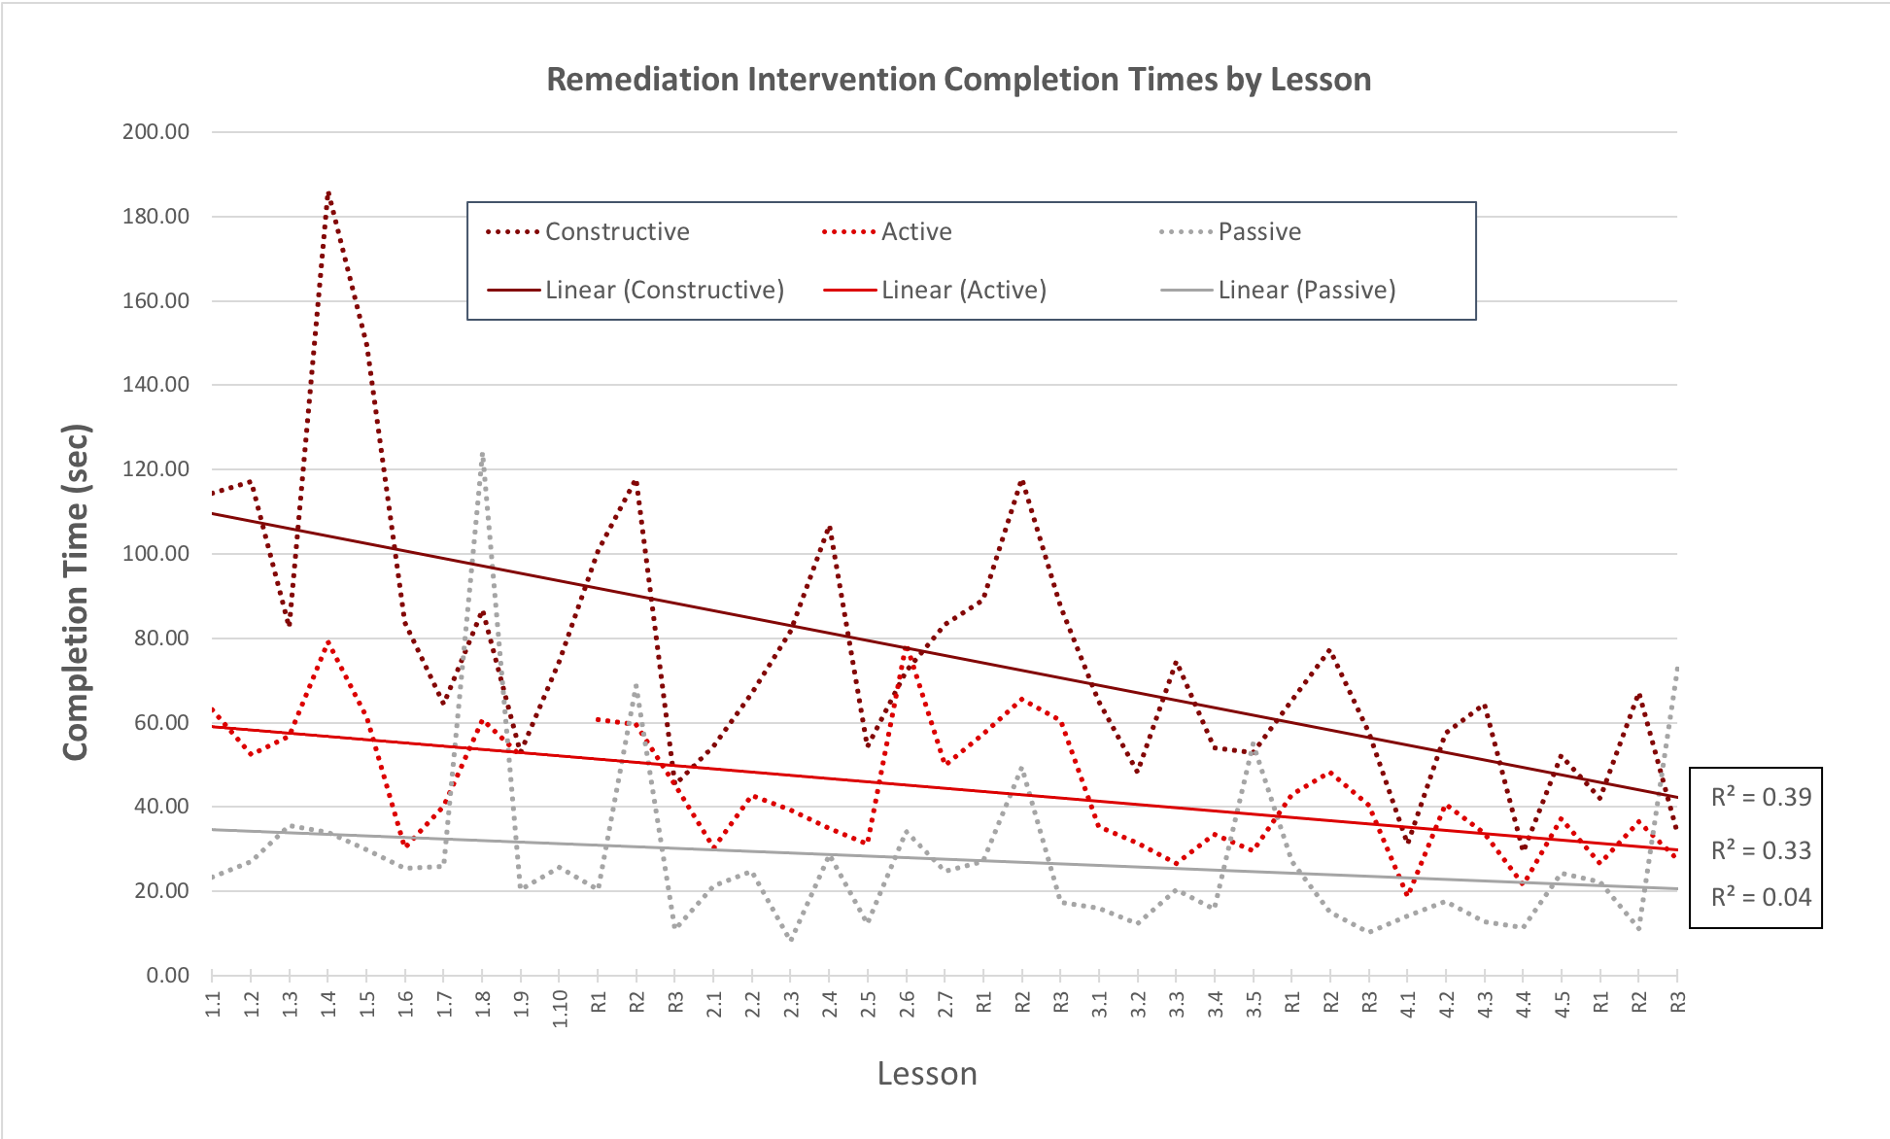
Figure 2: Remediation completion time across course lessons.
Finally, we conducted a set of exploratory analyses to identify which form of remediation was most effective at helping participants overcome an impasse for a missed recall item. We operationally defined remediation effectiveness as the proportion of cases in which participants correctly answered a recall question after receiving a given type of remediation (constructive, active, passive, none). We calculated remediation effectiveness in terms of the first, second, and third remediation instances delivered follow- ing missed attempts on a given recall question. As previously noted, participants continued to receive remediation until they demonstrated concept mastery. So, if a student missed a recall question, they continued to receive remediation until they answered the question correctly. By examining remediation effectiveness over successive attempts we aimed to identify trade-offs in remediation effectiveness that may have occurred as participants transitioned from one unsuccessful remediation attempt to another. The ICAP model predicts that constructive remediation should be more effective than active remediation at helping students overcome an impasse, and active remediation should be more effective than passive remediation. However, there could be tradeoffs between these different forms, as evident in the previous set of analyses that showed participants spent less time completing constructive and active remediation activities as they progressed through the course.
Our results generally supported the predictions of the ICAP model. Constructive remediation appeared to be more effective compared to active remediation at helping students overcome an impasse after one round of remediation, active remediation appeared to be more effective than passive, and passive reme- diation appeared to be more effective than no remediation (Figure 3). For cases in which participants received two rounds of remediation before correctly answered a recall question, constructive and active remediation appear to be the most effective form of remediation. Interestingly, presenting no remediation appeared to be more effective than presenting passive remediation. For cases in which participants correctly answered a recall question after the third remediation attempt, active remediation appeared to be more effective, followed by constructive remediation. There did not appear to be a major difference between passive and active remediation in terms of effectiveness.

Effectiveness of Remediation Intervention by Attempt
0.90

0.80

0.70

0.60
Remediation Effectiveness (normalized)

0.50
Constructive Active Passive
none

0.40

0.30

0.20

0.10

0.00
1st 2nd 3rd
Remediation Attempt
Figure 3: Remediation effectiveness across remediation attempts.
DISCUSSION AND LESSONS LEARNED
Our initial results are promising, and they suggest that the training corpus we collected using GIFT and Mechanical Turk contains a sufficient number of remediation interventions to explore data-driven tutorial planning models with reinforcement learning techniques. In addition, participants’ interaction behaviors with the remediation appeared to align with expected outcomes of the ICAP framework. Notably, partici- pants interacted with the constructive and active remediation content longer than the passive remediation content. The constructive and active remediation content also appeared to be more effective in helping learners overcome impasses during the course. Importantly, participants’ knowledge of COIN concepts improved from pretest to post-test.
To our knowledge this is the first time GIFT has been used with an online crowdsourcing platform to collect a large corpus of training data for machine learning analysis. By using MTurk, we were able to collect data from over 500 users over the course of a 4-week timespan. As we conducted the study, we adopted several best practices to ensure data were collected in an efficient and effective manner. First, we used multiple batches to collect data (approximately 15) and limited batch sizes to approximately 50 slots. This served two primary purposes: (1) it made monitoring the course and completion rates more manage- able for the research team, and (2) it allowed us to make changes to the course based on user feedback. Second, we closely monitored the email account associated with the MTurk profile and responded to all inquiries regarding the course. The MTurk user community is extremely responsive and forthcoming with feedback. Many participants shared recommendations for course improvements during our pilot testing phases as well as during testing. Participants frequently used the account’s email address to notify us if they experienced trouble completing the course or if they ran into difficulties submitting the completion code. By providing timely responses to participants, we were able to quickly address any unforeseen issues that participants experienced and maintain a high rating on many of the MTurk community forums where users review and rate MTurk tasks.
CONCLUSIONS AND RECOMMENDATIONS FOR FUTURE RESEARCH
Recent advances in ITS authoring tools, as well as data-driven tutorial planning, are showing significant progress toward reducing the effort required to create personalized learning experiences. A key next step is the development of computational methods and tools for automatically inducing pedagogical models that dynamically tailor learning experiences across different domains and learning environments. In this paper, we have reported preliminary results from a study conducted using GIFT and the Mechanical Turk crowdsourcing platform that was designed to collect a training corpus for inducing tutorial planning models in a hypermedia-based course using reinforcement learning techniques. Results suggest that ICAP-inspired feedback and remediation in the GIFT-based course broadly follows trends predicted by the ICAP model concerning instructional design and student cognitive engagement. However, results also suggest that the effectiveness of ICAP-inspired remediation may change over time and under different conditions, pointing toward the need for data-driven tutorial policies to control how and when different forms of remediation are delivered to learners. These findings set the stage for investigating the applica- tion of reinforcement learning techniques to automatically induce tutorial policies for controlling how and when ICAP-inspired remediation is delivered to learners.
There are several promising directions for future research and development of GIFT. One recommenda- tion is to expand the capability of Event Reporting Tool (ERT), which provides researchers with a means for extracting key data from users’ interaction logs. The ERT produces a record of all events that occurred during the GIFT session. Some of these events specify what the learner did; other events result from GIFT processing. While the log file from a GIFT session captures the interactions of GIFT, the log file must be transformed into another file in order to make it useful for analysis of learning effectiveness. Our team is currently working on an open source tool that will allow researchers to transform data from the ERT into a format that is amenable to reinforcement learning analysis. As GIFT’s user base continues to expand, it will become critically important to ensure researchers can easily access and analyze log data to investi- gate the effectiveness of different instructional inventions and tutorial policies.
ACKNOWLEDGEMENTS
The authors wish to thank Mike Hoffman for providing extensive assistance in developing GIFT software features that enabled this research. The research described herein has been sponsored by the U.S. Army Research Laboratory under cooperative agreement W911NF-15-2-0030. The statements and opinions expressed in this article do not necessarily reflect the position or the policy of the United States Govern- ment, and no official endorsement should be inferred.
REFERENCES

Aleven, V., McLaren, B., Sewall, J., & Koedinger, K. R. (2009). Example-tracing tutors: A new paradigm for intelligent tutoring systems. International Journal of Artificial Intelligence in Education, 19(2), 105.
Chi, M.T.H. (2009). Active-Constructive-Interactive: A conceptual framework of differentiating learning activities.
Topics in Cognitive Science, 1(1), 73-105.
Durlach, P. J., & Ray, J. M. (2011). Designing adaptive instructional environments: Insights from empirical evidence. Technical Report (1297) U.S. Army Research Institute for the Behavioral and Social Sciences; Arlington, VA.
Rowe, J., & Lester, J. (2015). Improving Student Problem Solving in Narrative Centered Learning Environments: A Modular Reinforcement Learning Framework. In Proceedings of the Seventeenth International Conference on Artificial Intelligence in Education, pp. 419-428.
Rowe, J., Spain, R., Pokorny, B., Mott, B., Goldberg, B., & Lester, J. (2018). Design and development of an adaptive hypermedia course for counterinsurgency training in GIFT: Opportunities and lessons learned. Proceedings of the Sixth Annual GIFT User Symposium (GIFTSym6), pp. 229-239.
Sottilare, R. (2015). Challenges to Enhancing Authoring Tools and Methods for Intelligent Tutoring Systems. In R. Sottilare, A. Graesser, X. Hu, and K. Brawner (Eds.). (2015). Design Recommendations for Intelligent Tu- toring Systems: Volume 3 - Authoring Tools and Expert Modeling Techniques. Orlando, FL: U.S. Army Research Laboratory.
Sottilare, R., Barr, A., Robson, R., Hu, X., & Graesser, A. (2018). Exploring the opportunities and benefits of standards for adaptive instructional systems (AISs). In Proceedings of the Adaptive Instructional Systems Workshop in the Industry Track of the 14th International Intelligent Tutoring Systems (ITS) Conference, pp. 49-53.
Sottilare, R. A., Brawner, K. W., Goldberg, B. S., & Holden, H. K. (2012). The generalized intelligent framework for tutoring (GIFT). U.S. Army Research Laboratory–Human Research & Engineering Directorate (ARL- HRED).
Sottilare, R. A., Brawner, K. W., Sinatra, A. M., & Johnston, J. H. (2017). An updated concept for a generalized intelligent framework for tutoring (GIFT). Retrieved from www.gifttutoring.org
Sutton, R. S., & Barto, A. G. (1998). Reinforcement learning: an introduction MIT Press. Cambridge, MA. Williams, J. J., Kim, J., Rafferty, A., Maldonado, S., Gajos, K., Lasecki, W., & Heffernan, N. (2016). AXIS:
Generating Explanations at Scale with Learner sourcing and Machine Learning. Proceedings of the 3rd An- nual ACM Conference on Learning at Scale, Edinburgh, SCT, pp. 379-388.
Zhou, G., Wang, J., Lynch, C., & Chi, M. (2017). Towards closing the loop: Bridging machine-induced pedagogical policies to learning theories. In Proceedings of the Tenth International Conference on Educational Data Mining (pp. 112-119).
ABOUT THE AUTHORS
Dr. Randall Spain is a Research Psychologist in the Center for Educational Informatics at North Carolina State University where he uses principles, theories, and methods of applied psychology (human factors, educational psychology, personnel psychology, experimental psychology, and psychometrics) to design and evaluate the impact of advanced training technologies on learning and performance. He has conducted training and human factors research for the Department of Defense and the Department of Homeland Security for the past 10 years with a focus on adaptive training, performance assessment and measurement, user modeling and human-automation interaction. Dr. Spain is a PhD graduate from Old Dominion University’s Human Factors Psychology program and serves on the editorial board for Military Psychology.

Dr. Jonathan Rowe is a Research Scientist in the Center for Educational Informatics at North Carolina State University, as well as an Adjunct Assistant Professor in the Department of Computer Science. He received the PhD and MS degrees in Computer Science from North Carolina State University, and a BS degree in Computer Science from Lafayette College. His research is in the areas of artificial intelligence and human-computer interaction for advanced learning technologies, with an emphasis on game-based learning environments, intelligent tutoring systems, multimodal learning analytics, user modeling, educational data mining, and computational models of interactive narrative generation. Dr. Rowe also serves on the editorial boards of the International Journal of Artificial Intelligence in Education and IEEE Transactions on Learning Technologies.

Dr. Benjamin Goldberg is a senior researcher in the Learning in Intelligent Tutoring Environments (LITE) Lab at the Combat Capabilities Development Command (CCDC) Soldier Center, Simulation and Training Technology Center (STTC) in Orlando, FL. He has been conducting research in modeling and simulation for the past eight years with a focus on adaptive learning and how to leverage artificial intelligence tools and methods for adaptive computer-based instruction. Currently, he is the LITE Lab’s lead scientist on instructional strategy research within adaptive training environments. Dr. Goldberg holds a PhD from the University of Central Florida in Modeling & Simulation.

Dr. Robert Pokorny is Principal of the Education and Training Technologies Division at Intelligent Automation, Inc. He earned his PhD in Experimental Psychology at the University of Oregon in 1985, and completed a postdoc- toral appointment at the University of Texas at Austin in Artificial Intelligence. His first position after completing graduate school was at the Air Force Research Laboratory, where he developed methodologies to efficiently create intelligent tutoring systems for a wide variety of Air Force jobs. At Intelligent Automation, Bob has led many cognitive science projects, including adaptive visualization training for equipment maintainers, and an expert system approach for scoring trainee performance in complex simulations.

Dr. James Lester is Distinguished Professor of Computer Science at North Carolina State University, where he is Director of the Center for Educational Informatics. His research centers on transforming education with technolo- gy-rich learning environments. With a focus on adaptive learning technologies, his research spans intelligent tutoring systems, game-based learning environments, affective computing, and tutorial dialogue. The adaptive learning environments he and his colleagues develop have been used by thousands of students in K-12 classrooms. He received his PhD in Computer Science from the University of Texas at Austin in 1994. He is a Fellow of the Association for the Advancement of Artificial Intelligence (AAAI).

