Paper Title

Author¹, Author²
Organization¹, Organization²
Introduction
An introduction section is required to provide background to the reader about your paper and its context relative to GIFT. No abstract is to be included in your paper submission. You may used your accepted abstract as the basis for your introduction.
Each paragraph is to be separated by a single spaced line. Please, only use the styles provided in the gallery above. Text is the style to be used for the body of your paper.
Second Level Heading
Text is the style to be used for the body of your paper.
Third Level Heading
Text is the style to be used for the body of your paper.
Fourth Level Heading
Text is the style to be used for the body of your paper. Please do not go deeper than four heading levels.

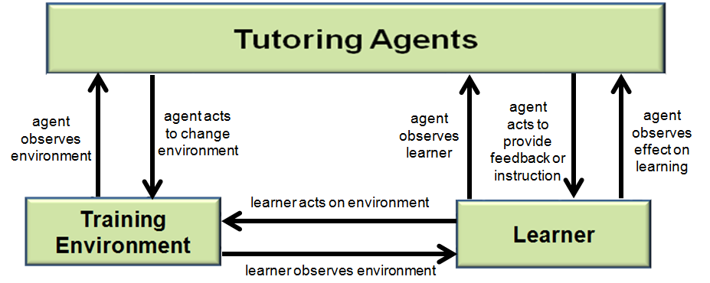
Figure 1. Use Caption Style for Figures and Tables
Note: Figure captions go below the figure (centered) and table captions go above the figure (centered).
Conclusions and Recommendations for FUTURE research
Note: Please provide conclusions and recommendations for future directions for GIFT and ITS research.
References
Note: Please use reference style provided… it will automatically place a 6pt space between each reference.
Sottilare, R. and Gilbert, S. (2011). Considerations for tutoring, cognitive modeling, authoring and interaction design in serious games. Authoring Simulation and Game-based Intelligent Tutoring workshop at the Artificial Intelligence in Education Conference (AIED) 2011, Auckland, New Zealand, June 2011.
Sottilare, R., Brawner, K., Goldberg, B. & Holden, H. (2012). The Generalized Intelligent Framework for Tutoring (GIFT). US Army Research Laboratory.
Sottilare, R., Goldberg, B., Brawner, K., & Holden, H. (2012). A modular framework to support the authoring and assessment of adaptive computer-based tutoring systems (CBTS). In Proceedings of the Interservice/Industry Training Simulation & Education Conference, Orlando, Florida, December 2012.
Sottilare, R., Holden, H., Goldberg, B., & Brawner, K. (2013). The Generalized Intelligent Framework for Tutoring (GIFT). In Best, C., Galanis, G., Kerry, J. and Sottilare, R. (Eds.) Fundamental Issues in Defence Simulation & Training. Ashgate Publishing.
VanLehn, K., Lynch, C., Schulze, K., Shapiro, J. A., Shelby, R., Taylor, L., et al., (2005). The Andes physics tutoring system: Lessons learned. International Journal of Artificial Intelligence and Education, 15(3), 147–204.
VanLehn, K. (2011): The Relative Effectiveness of Human Tutoring, Intelligent Tutoring Systems, and Other Tutoring Systems, Educational Psychologist, 46:4, 197-221
Vygotsky, L.S. (1978). Mind in Society: The development of higher psychology processes. Cambridge MA: Harvard University press.

ABOUT THE AUTHORS
Note: Please provide a short (<100 word) bio for each author listed in your paper… use author bio style and bold the author’s title and name… see example below:
Dr. Robert Sottilare leads adaptive training research within ARL’s Learning in Intelligent Tutoring Environments (LITE) Lab and is a co-creator of the Generalized Intelligent Framework for Tutoring (GIFT).

